**SMART DOOR LOCK SYSTEM FOR VISUALLY CHALLENGED PERSON USING IOT**

**MINI PROJECT REPORT**

***Submitted by***

**GAYETHRI.V REGISTER NO: 20TD0327**

**RAJASRI.N REGISTER NO: 20TD0373**

**SINDHUJA.B REGISTER NO: 20TD0388**

***Under the guidance of***

**Mrs . S . Boovaneswari , M.Tech.,**

*Assistant Professor ,CSE*

***in partial fulfillment for the award of the degree***

***of***

**BACHELOR OF TECHNOLOGY**

***in***

**DEPARTMENT OF COMPUTER SCIENCE AND ENGINEERING**



**MANAKULA VINAYAGAR INSTITUTE OF TECHNOLOGY,**

**KALITHEERTHALKUPPAM, PONDICHERRY**

**PONDICHERRY UNIVERSITY, INDIA.**

**JUNE 2023**

**MANAKULA VINAYAGAR INSTITUTE OF TECHNOLOGY**

**PONDICHERRY UNIVERSITY**

**DEPARTMENT OF COMPUTER SCIENCE AND ENGINEERING**

**BONAFIDE CERTIFICATE**

This is to certify that the project work entitled **“SMART DOOR LOCK SYSTEM USING IOT”** is a bonafide work done by **GAYETHRI.V [REGISTERNO: 20TD0327 ], SINDHUJA.B [REGISTER NO: 20TD0388 ], RAJASRI.N [REGISTER NO: 20TD0373]**  in partial fulfillment of the requirement for the award of B.Tech Degree in Computer Science And Engineering by Pondicherry University during the academic year 2022 -23.

**HEAD OF THE DEPARTMENT PROJECT GUIDE**

Dr. S. PARISELVAM, M.E, Ph.D., Mrs.S. BOOVANESWARI ,M.Tech.,

HOD/CSE Assistant Professor,

Department of CSE

**MINI PROJECT COORDINATOR**

Mrs.I. VARALAKSHMI ,M.Tech., (Ph.d)

Assistant Professor,

Department of CSE

**ACKNOWLEDGEMENT**

We express our deep sense of gratitude to **TheivaThiru. N. Kesavan,** Founder, **Shri. M. Dhanasekaran,** Chairman & Managing Director**, Shri. S. V. Sugumaran,** Vice-Chairman and **Dr. K. Gowtham Narayanasamy** Secretary of **Sri ManakulaVinayagar Educational Trust, Puducherry** for providing necessary facilities to successfully complete our project and report works.

We express our sincere thanks to our beloved Principal **Dr. S. Malarkkan** for having provided necessary facilities and encouragement for successful completion of this project work.

We express our sincere thanks to **Dr.S.Pariselvam Professor and Head of the Department**, **Computer Science and Engineering** for his support in making necessary arrangements for the conduction of Project and also for guiding us to execute our project successfully.

We express our sincere thanks to **Mrs.S.Boovaneswari ,Assistant Professor**, **Computer Science and Engineering** for her consistent reviews which motivated us in completing project.

We express our sincere thanks to Mini project Coordinator **Mrs.I.Varalakshmi, Assistant Professor**, **Computer Science and Engineering** for her consistent reviews which motivated us in completing project.

We thank all our department faculty members, non-teaching staffs and my friends of Computer Science and Engineering for helping us to complete the document successfully on time.

We would like to express our eternal gratitude to our parents for the sacrifices they made for educating and preparing us for our future and their everlasting love and support.We thank the Almighty for blessing us with such wonderful people and for being with us always.

**ABSTRACT**

A digital door lock system is equipment that uses the digital information such as a secret code, semi-conductors, smart card, and finger prints as the method for authentication instead of the legacy key system. Conceptual Security has consistently been a significant worry to the general public either in the family units or the workplace condition. There are different methodologies set up to address these issues. This venture is proposed to build up a savvy locking framework utilizing the Internet of Things. Utilizing conventional keyed locks is basic since the start of human kind, anyway there is a high risk of keys being lost or getting into inappropriate hands. Subsequently, many individuals prefer biometric locks over traditional keyed locks to improve the security of their homes or workplaces. In contrast to the conventional lock, a cutting-edge biometric lock requires no key to bolt or open the door and instead uses a biometric sensor. Our project is an ESP32 Camera Module based adaptable working device that provides physical security utilizing the relay module which is help to connect the solenoid lock with ESP32 Module .As the door lock is the first and last thing people come across in entering and leaving the home respectively, the home automation function in digital door lock system enables user to conveniently control and monitor home environment and condition all at once before entering or leaving the house. Furthermore, it also allows users to remotely monitor the condition inside the house through Internet or any other public network. The biggest advantage of our proposed system over existing ones is that it can be easily installed when and where necessary without requirement of any infrastructures and proper planning. The ESP 32 camera module detects the authorized person while opening the door. The main purpose of this system is for visually challenged people can able to use easily.

|  |  |  |  |  |
| --- | --- | --- | --- | --- |
|  | **TABLE OF CONTENTS** | | |  |
|  |  | | |  |
| **CHAPTER NO.** | **TITLE** | | | **PAGE NO.** |
|  |  |  | ACKNOWLEDGEMENT | iii |
|  |  |  | ABSTRACT | iv |
|  |  |  | TABLE OF CONTENT | v |
|  |  |  | LIST OF FIGURES | vii |
|  |  |  | LIST OF ABBREVIATION | viii |
| **1** |  |  | **INTRODUCTION** | **1** |
|  | 1.1 |  | OVERVIEW | 1 |
|  | 1.2 |  | TECHNOLOGY | 1 |
|  | 1.3 |  | ARCHITECHTURE | 2 |
|  |  | 1.3.1 | NECESSITY | 2 |
|  |  | 1.3.2 | ADVANTAGES | 2 |
|  | 1.4 |  | MOTIVATION | 3 |
|  | 1.5 |  | PROJECT OBJECTIVE | 3 |
| **2** | 2.1  2.2  2.3  2.4 |  | **LITERATURE SURVEY**  QR BASED ADVANCED AUTHENTICATION FOR ONLINE TRANSACTIONS  A LOCKING SYSTEM USING BLUETOOTH TECHNOLOGY AND CAMERA VERIFICATION  IOT BASED SMART WIRELESS HOME SECURITY SYSTEMS  A REVIEW ON QR CODE ANALYSIS | 4  4  4  6  6 |
| **3** |  |  | **EXISTING WORK** | 7 |
|  | 3.1 |  | OVERVIEW | 7 |
|  | 3.2 |  | EXISTING WORK | 7 |
|  | 3.3 |  | DRAWBACK OF THE EXISTING METHOD | 10 |
| **4** |  |  | **PROPOSED SYSTEM** | **11** |
|  | 4.1 |  | OVERVIEW | 11 |
|  | 4.2 |  | PROPOSED SYSTEM | 11 |
|  | 4.3 |  | PROPOSED ALGORITHM | 12 |
|  | 4.4 |  | SYSTEM MODEL | 13 |
|  | 4.5 |  | FLOWCHART OF THE SYSTEM | 14 |
|  | 4.6 |  | NETWORK ARCHITECTURE | 15 |
| **5** |  |  | **SYSTEM IMPLEMENTATION** | **17** |
|  | 5.1 |  | HARDWARE DESCRIPTON | 17 |
|  |  | 5.1.1 | CAMERA MODULE ESP32 | 17 |
|  |  | 5.1.2 | SOLENOIDAL LOCK | 17 |
|  |  | 5.1.3 | PIEZO BUZZER | 18 |
|  |  | 5.1.4 | ADAPTER | 19 |
|  |  | 5.1.5 | HC05 BLUETOOTH MODULE | 19 |
|  |  | 5.1.6 | RELAY MODULE | 20 |
|  | 5.2 |  | SOFTWARE DESCRIPTION | 21 |
|  |  | 5.2.1 | NODE MCU WITH ARDUINO IDE(ESP32 SETUP) | 21 |
|  |  | 5.2.2 | PYTHON | 23 |
|  |  | 5.2.3 | ARDUINO VOICE CONTROL APP | 24 |
| **6** |  |  | **PERFORMANCE ANALYSIS** | **25** |
|  | 6.1 |  | OVERVIEW | 25 |
|  | 6.2 |  | AUTHENTICATION SPEED RESULTS | 25 |
|  | 6.3 |  | THE SECURITY PERFORMANCE RESULTS | 26 |
| **7** |  |  | **CONCLUSION** | **28** |
|  | 7.1 |  | CONCLUSION | 28 |
|  | 7.2 |  | SCOPE FOR FUTURE WORK | 28 |
|  |  |  | **REFERENCES** | **29** |
|  |  |  | **APPENDIX-1(CODING)**  **APPENDIX-2(SCREENSHOT)** | **31**  **36** |
|  |  |  | **MINI PROJECT EXPO** | **42** |

**LIST OF FIGURES**

|  |  |  |
| --- | --- | --- |
| **FIGURE NO** | **TITLE** | **PAGE NO** |
| 1.1 | SYSTEM ARCHITECTURE DIAGRAM | 2 |
| 3.1 | BLOCK DIAGRAM OF FACE RECOGNIZATION | 7 |
| 3.2 | BLOCK DIAGRAM OF FINGERPRINT | 8 |
| 3.3 | BLOCK DIAGRAM OF ACCESS | 9 |
| 3.4 | ARCHITECTURE OF KEYPAD | 9 |
| 4.1 | SYSTEM MODEL | 13 |
| 4.2 | FLOW CHART | 14 |
| 4.3 | NETWORK ARCHITECTURE | 15 |
| 4.4 | PROCESS OF UNLOCK THE DOOR | 16 |
| 5.1 | CAMERA MODULE(ESP 32) | 17 |
| 5.2 | SOLENOIDAL LOCK | 18 |
| 5.3 | PIEZO BUZZER | 18 |
| 5.4 | ADAPTER | 19 |
| 5.5 | HC-05 BLUETOOTH MODULE | 19 |
| 5.6 | RELAY | 20 |
| 5.7 | ARDUINO VOICE CONTROL CONNECTION | 24 |
| 6.1 | FACE ENROLLING WEBPAGE | 27 |
| 6.2 | HARDWARE KIT | 27 |

**LIST OF ABBREVIATIONS**

|  |  |
| --- | --- |
| DC | Direct Current |
| LED | Light Emitting Diode |
| IoT | Internet of Things |
| ID | Identification |
| CV | Computer Vision |
| QR | Quick Response |
| RAC | Residential Access Control |
| WIFI | Wireless Fidelity |
| VIN | Input voltage |
| GND | Ground |
| VCC | Power supply |
| LAN | Local area network |
| SD | Secure Digital |
| IDE | Integrated Development Environment |
| IOS | Iphone Operating System |

**CHAPTER 1**

**INTRODUCTION**

* **OVERVIEW**

Every living being wishes to be safe whether it is a safety related to his belongings or safety of his own precious life. We have been taking several measures in order to attain it to live a worry-free life. In this project we propose a smart locking system which is designed to work based on the Internet of Things to prevent unauthorized access and trespassing. Normally the common targets where unauthorized access takes place are Banks, Financial organization, Government offices and organization, and shops. Such activities are performed with an intention of stealing money, or any important documents for personal gain. The main aim of our project is to provide a useful and a feasible solution to many of such issues.

**1.2 TECHNOLOGY**

Smart home technology is to improve living conditions by introducing networking tools and equipment within the home. A smart house allows for complete automation, resulting in comfortable living conditions and additional advantages for those with disabilities. Every door locking system now in use requires a traditional key or some other type of Node MCU to access the system.

By creating an HTML webpage, users can access the door lock and open or close it. It supports IOT, cellular technology, and a non-proprietary open-source Android operating platform. The proposed viewpoint registers, as well as the essential architecture, to work with Wi-Fi technology for integration, an Android-based App for client ingress, and client testimonials for dependability and verification.

**1.3 ARCHITECHURE**

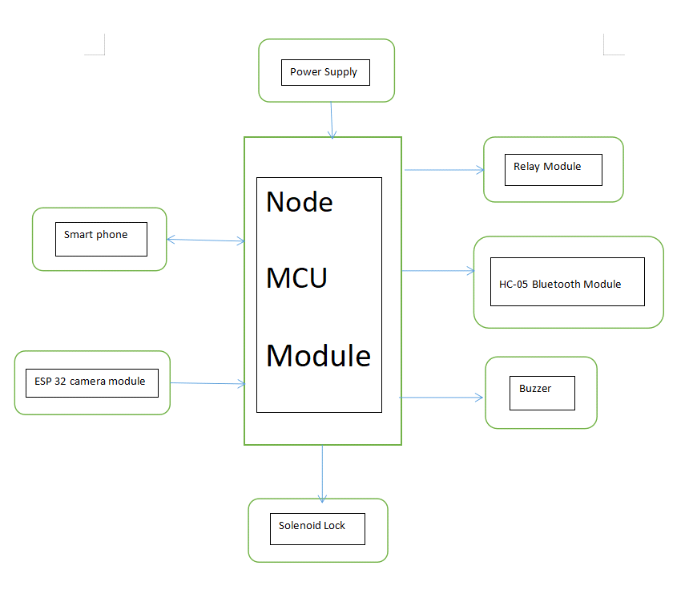

**Figure: 1.1 System architecture diagram**

**1.3.1 Necessity**

Smart locks leverage IoT-enabled sensors to operate keyless entry devices that allow users to access doors remotely, through a smartphone or other internet-connected device. Smart locks provide users the ability to unlock their door without a key, from anywhere, as well as distribute virtual keys to visitors. The need for security and convenience is one of the main reasons why people convert their houses into smart homes. And some of the easiest and most accessible devices to incorporate into a smart home are smart door locks. They are an easy upgrade that will make your life easier and your home much safer.

**1.3.2 Advantage:**

* Check on the status of a door remotely, ensuring that it is locked no matter how far from home they are.
* Give and revoke remote access to visitors, enabling service providers to access the door only at specific times, or to give unlimited access to trusted friends or family.
* Receive notifications whenever the door is opened – allowing users to be immediately alerted in case of unexpected access.

**1.4 MOTIVATION**

Our project motivation is to handle or access the door lock using smart phone. In addition, we focus on understanding the goal of our project were to build a modern, easy to use access and smart door lock that allows for accessible the door to locking and unlocking the door with added convenience for different access modes as well The need for security and convenience is one of the main reasons why people convert their houses into smart homes

**1.5 PROJECT OBJECTIVE**

The goal of this project is to research and analyze a suitable collection of components for developing a smart door lock using Arduino that provides excellent security and quick access. Every door locking system now in use requires a traditional key or some other type of Node MCU to access the system. By creating an HTML webpage, users can access the door lock and open or close it. The following are the specific project goals:

* Familiarity with a smart door locking system based on a microcontroller.
* Using Arduino to create a simple and smart door locking system.

**CHAPTER 2**

**LITERATURE SURVEY**

This paper suggests a technology that will make human lives more versatile by enhancing security, ease, and the ability to live an upper-class lifestyle, resulting in our lives becoming much simpler, nicer, more accessible, and consistent. It shows inventiveness in house control by replacing manual keys with digital codes and knocks for a door lock at home, anticipating future security trends and replacing hi-tech manual locks with Digital Smart Locks. Furthermore, the implementation expenses of the developed system have been maintained to a minimum, making it accessible to anyone looking for home protection. The Digital Smart Home, in contrast to the rest of the technologies described in the literature review,It's simple to manage and implement. It supports IOT, cellular technology, and a non-proprietary open-source Android operating platform.The proposed viewpoint registers, as well as the essential architecture, to work with Wi-Fi technology for integration, an Android-based App for client ingress, and client testimonials for dependability and verification. The structure laid out might then be developed to encompass other facets of house remodeling and dependability. Additionally, these research projects are routinely supplemented to accommodate non-Android operating systems.

**2.1 QR Based Advanced Authentication for Online Transactions:**

Priyanka Bhogade, “QR Based Advanced Authentication for OnlineTransactions”, International Journal of Engineering Research &amp; Technology(IJERT), Vol. 3, Issue. 2, February 2014.The model is proposed with QR codes isthat, there is lack of awareness among corporate world about people interested todevelop and use QR code. QR code based authentication is beneficial to user costeffective and less time consuming. Moreover there is no need to carry Externaldevice (such as scanner). Available ID password and OTP are used for authentication which is not secured ever. QR code based authentication system that runs on all hardware platforms such as PC, tablets, smart phones etc. This system contains three modules that are Creation, Authentication and Transaction.

**2.2 A Locking System Using Bluetooth Technology and Camera Verification:**

Bhalekar Pandurang, Jamgaonkar Dhanesh, Prof. Mrs. Shailaja Pede, GhangaleAkshay, Garge Rahul, “Smart Lock: A Locking System Using Bluetooth Technology and Camera Verification”, The new generation is now full of smart people using smart technology. Smart devices makes life of a person easy and updated. There are hundreds of goods available today that allow us have power over the devices without human intervention, either by remote control; or even by voice command. So in ”Smart Lock” an ARM7 controller and Bluetooth module from the mobile device is used for smart lock system. The proposed system describes improvement of a security system that is integrated with an Android mobile phone device using Bluetooth as a wireless connection protocol. Android OS is currently the go ahead on mobile market share while Symbian OS was already discontinued. This proposed system allows a user to lock or unlock a door a short range from the door. The application was designed to allow the user to also check the status of the door. The mobile device requires a password to increase the security of the system. The hardware on the door uses a microcontroller to control a linear actuator that acts as the locking mechanism. The Bluetooth protocol was chosen as a communication method because it is already integrated into many Android devices and is secured through the protocol itself. It also fits well into the design requirements of the project for a short range, wireless connection method.

**2.3** **Iot Based Smart Wireless Home Security Systems:**

Kushank Sehgal and Richa Singh, “Iot Based Smart Wireless Home Security Systems” Proceedings of the Third International Conference on Electronics Communication and Aerospace Technology.The main aim is to make our homes smarter and more secured. the technology or concept for this paper is basically IOT and cloud-based services which are a thing of present and future. Home automation. system has achieved much more popularity in the past decades has focused on mainly improving quality of life overall. The IOT based devices will help in surveillance and energy management and also provides support for a direct message or SMS to nearby friends and support with GPS location and predefined message just by a single tap of user. All these operations are controlled by cloud system with active internet support.

**2.4** **A Review on QR Code Analysis:**

Chinmay Jathar, Swapnil Gurav and Krantee Jamdaade, “A Review on QR Code Analysis” International Journal of Application Innovation in Engineering and Management (IJAIEM).Quick Response code is usually authenticated with the help of the camera of one’s mobile phone. QR codes can easily scanned through mediums like Tablets, laptops and personal computer desktops. The system automatically generates the ID of the user and its password. The characteristic which makes QR codes stand out is they can still be scanned even if they are partially damaged. QR codes are a 2 dimensional printing code on a paper or a screen which makes it pretty vulnerable from various type of cyber-attacks. It can harm your device by unknowingly directing you to a virus contaminated page or website. To avoid this, one must verify the origin of a particular QR code and must have a full understanding of the data type of that particular QR code. There are many attacks involving QR codes as well as their solutions. QR codes are becoming quite popular nowadays because of the rapid increase in smart devices by the normal people around the world. Obviously, 2D QR code is way better and store huge amount of encoded information compared to the old traditional 1D codes. People are using smartphones to do authentications and for this the QR codes are the most ideal way to do it.

**CHAPTER 3**

**EXISTING WORK**

**3.1 OVERVIEW**

The idea behind the modern day smart locks is to unify the functionality provided by convenient and secure access control methods with the convenience of internet connectivity and remote control. There are a few products on the market that offer these systems and we will talk about some of them, once again focusing on the features they offer and potential disadvantages, as these products will serve as inspiration for our actual product implementation. An overview of different smart lock technologies. The smart lock system being adopted in many homes and other commercial buildings today is an innovative approach that provides many user-friendly benefits with its tolerable downsides

**3.2 EXISTING WORK**

**A. Smart IOT-based Facial Recognition Door Lock System**

A smart IOT-based facial recognition system is a proactive approach that can take immediate action upon a security threat. The system recognizes the face of that person nearby the door and compares it with the faces uploaded to the database. A message and email with an intruder image will be sent to the owner in the event that an unknown person enters the building. This system uses Raspberry Pi, a Pi camera that is installed near the door to recognize an intruder's face, Direct Current (DC) motors connected through relays to open the door, Light-Emitting Diodes (LED) to indicate whether the door is open, and a GSM module is used to send texts to the registered mobile number.

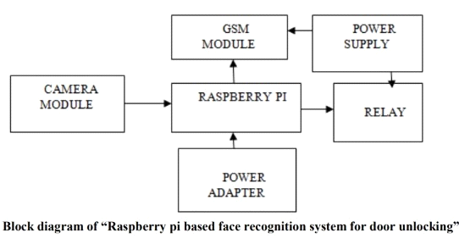

**Figure:3.1 Block diagram of face recognition**

1. **Fingerprint Door Locking System**

* Fingerprints are widely considered as a unique identification of a person and the fastest and easiest method of biometric identification. Due to the fact that they are so unique and don't change for one in a lifetime, they areso secure and reliable to use.
* As long as the minutiae matching technique is used appropriately, fingerprint recognition can be cheap,reliable,and accurate.A minutiae matching approach is used in this thesis work for fingerprint matching.
* The main difference between this algorithm and other conventional minutiae matching algorithms is the fact that it takes account of region and line structures between minutiae pairs. More structural information about the fingerprint should be accounted for to increase the certainty of matching minute.

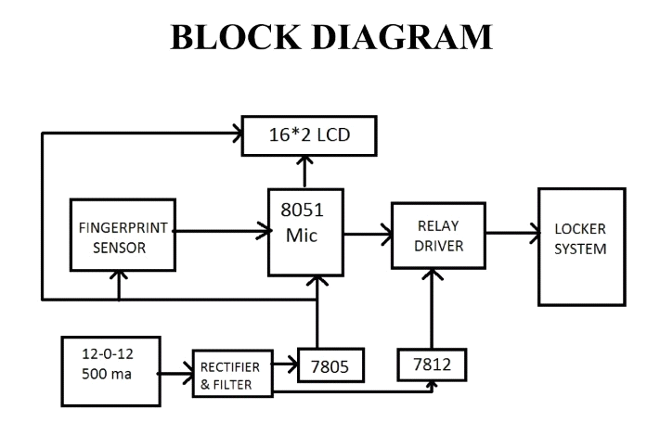

**Figure: 3.2 Block diagram of fingerprint**

**C. Access Cards and Card Readers**

There are a number of different card reader types. Some common ones include magnetic stripes, barcode, etc. Magnetic stripe cards have a magnetic band laminated to the back of the card. The card can contain a code, which serves for identification, the person’s name, and other useful data, although only the ID code is commonly encoded. ID cards are effective, simple to build, and cheap, but they are very easy to duplicate. Other types of ID cards work in a very similar way to magnetic stripe.

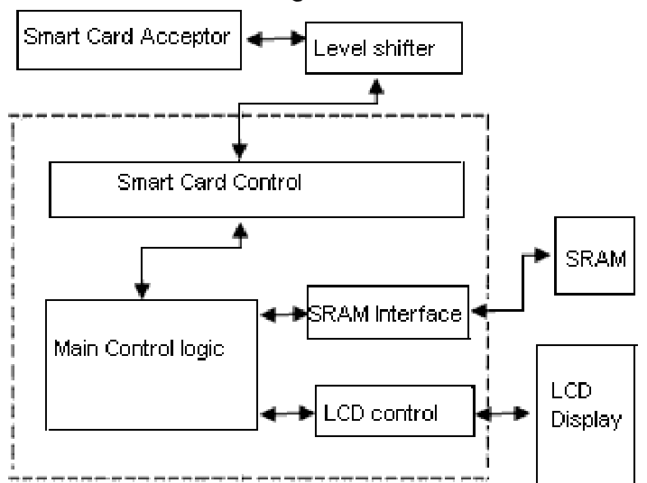

**Figure: 3.3 Block diagram of Access Card**

**D.Keypad**

The most basic types of ID readers are keypads, based on simple twelve-digit keypads, containing the numbers 0-9 and a * and # sign, shown in figure. These types of access control locks are very simple and cheap, and over time they have advanced to include some more secure functionality, like scrambling the LED number keys on the keyboard so that others who can detect the gesture and movement wouldn’t be able to use it. The main disadvantage include people’s need to share the code, like with family members or friends.

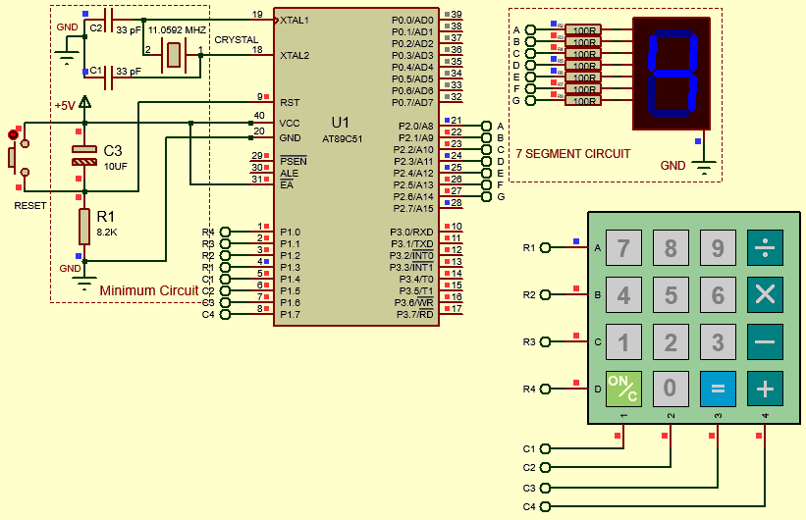

**Figure: 3.4 Architecture of keypad**

**3.3 DRAWBACKS OF EXISTING METHOD:**

* The existing method uses the Arduino board as a main system and sends the SMS alerts to the user/owner. The SMS can only alert the owner about the time of the intrusion.
* It cannot send the visual image of the intruder to the owner which is the major drawback of the method. The Arduino doesn’t support Python which we need for OpenCV module for QR Code scanner.
* OpenCV module consists of all the requirements for the Image recognition, video capturing and scanning the QR and Barcode.

**CHAPTER 4**

**PROPOSED WORK**

**4.1 OVERVIEW**

Face Recognition are emerging as an ideal authentication option for door entry systems – particularly for temporary applications and time-limited access permission situations such as managing entry for staff, contractors. when access to the building may be restricted to certain days of the week, certain times of the day. Internet of things (IOT) technology has begun to play more roles in people’s daily lives, as seen in the popularity of IOT equipment. Besides, smartphones have become indispensable for many people since they are capable of processing instructions similar to a computer and communicating via wireless networks such as Wi-Fi . A safe access control system can be created using encryption technology and IOT applied to a smartphone. We aimed to develop a residential access control system (RACs) using Face recognition and the IOT for authentication and develop an Android smartphone application to create an authentication key. The device that controls the door will scan the face of the person. The application has a system that can allow home users to manage the devices that are allowed to access the home. The encryption uses smartphone-specific information authentication. Moreover, the RACs can notify the house owners via the LINE application when someone enters or leaves the residence, and the house owners can view the status of the devices through the dashboard. This system is convenient for accessing residences and can reduce the trouble of carrying keys or forgetting keys. It can also increase residential security.

**4.2 PROPOSED SYSTEM**

Keyless Door Entry is increasingly popular for its flexibility both for the user and system administrator. Unique QR codes can quickly and easily be generated from a smart phone or PC app and emailed to the user in any location around the world – no physical ‘key device’ is necessary.

Where high numbers of users and frequent temporary access permissions requires a significant amount of system management and administration, the ability to create and distribute access of a door using voice control app can use remotely from anywhere in the world allows for a highly efficient system management solution**.**

Access facial of a person can be set for time-limited and number-of-use limited entry – ideal for one-time-only delivery access or cleaning contractors, for example, who only require entry on a specific day of the week. By scanning the face of a person from camera module supports the trend for contactless door entry to help prevent the transmission of germs and viruses**.**

Facial recognition effectively provide a ‘virtual key’, removing any requirement for physical keys, single-use plastics such as ID cards or keyfobs, or printing on paper; thereby providing a notable reduction in overall environmental impact from your security system This virtual key option reduces staff resource requirement, distribution time and the requirement for physical identity to key devices, thereby significantly reducing ongoing costs.

**4.3 PROPOSED ALGORITHM**

This algorithm has been applied in this work as a one of the methods that is used for a string comparison because it is most efficient and accurate in similarity metrics [11]. The Jaro Winkler algorithm has been used for matching two strings which contain spelling mistakes and find approximation of common matched characters. The result value of this algorithm is

always returned between 0 and 1, the strings are identical when the result value is 1 only.

Where s and t are the strings need to compare. And Jaro Winkler string comparator is calculated in equation (2).

Where a and b are the string need to be compared, P is Winkler constant (P<0.25), and N is the number of character similarity [13]. An example of comparison two strings using Jaro Winkler algorithm has been explained below in details.

To compare two strings s=MARTHA, and t=MARHTA, by applying equation (1) to find Jaro value:

M=6, is number of matching characters

SL=6, is the length of first string (s)

TL=6, is the length of second string (t)

MS=1, is the mismatch characters (2/2=1)

Now, applying equation (2) to find the Jaro Winkler value as below:

P= 0.1, Jaro Winkler constant

MT=3, number of prefix match

In our work, these steps of algorithm has been applied in Arduino language platform based on Java to compare both registered password with password sent from smart phone device via Bluetooth where try to lock/unlock door actuator. In addition to that, a threshold value has been set for authentication access where score of W should not be less than 0.9.

**4.4 SYSTEM MODEL**

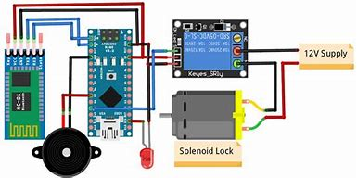

**Figure: 4.1 System model**

Connections for this IOT**Smart Door Lock** are very simple as we are only connecting a solenoid lock, relay module, and a buzzer with Node MCU ESP8266. The input pin of the relay is connected to the D5 pin of Node MCU while VCC and Ground pins are connected to VIN and GND pin of Node MCU. The positive pin of the buzzer is connected to the D6 pin of camera module , HC05 Bluetooth module and the GND pin is connected to the GND of Camera module.

It's simple to manage and implement. It supports IOT, cellular technology, and a non-proprietary open-source Android operating platform. The proposed viewpoint registers, as well as the essential architecture, to work with Wi-Fi technology for integration, an Android-based App for client ingress, and client testimonials for dependability and verification. The structure laid out might then be developed to encompass other facets of house remodeling and dependability. Additionally, these research projects are routinely supplemented to accommodate non-Android operating systems.

**4.5 Flow chart of the system**

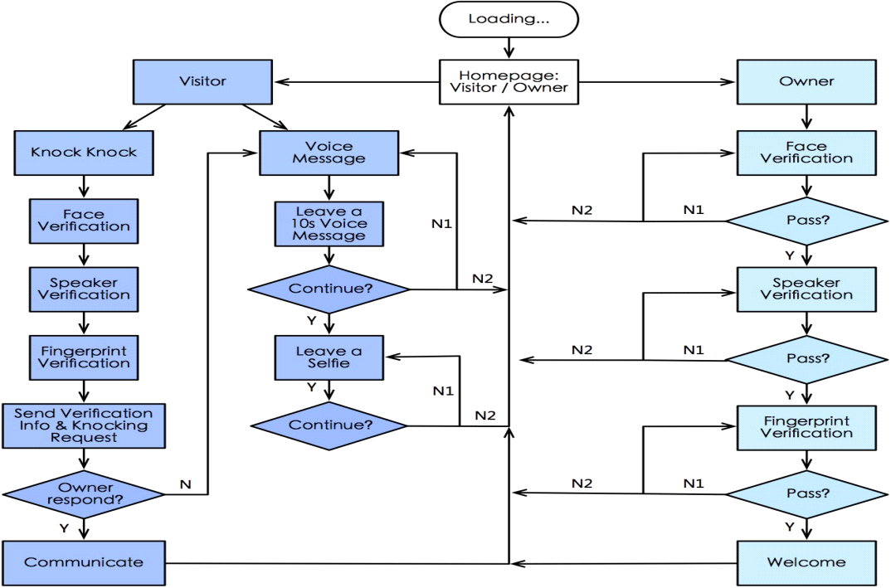

**Figure:4.2 Flowchart**

In our project, we implemented a door locking and unlocking system that can be controlled remotely via a mobile application. A solenoid lock, a single-channel 12v relay, a Camera ESP32 module, and a 12v dc converter were utilized. A solenoid lock can be activated automatically by applying voltage to it. When an interrupt is activated in a solenoid lock, a low-voltage solenoid pulls the latch back into the door. The latch will remain in place until the interrupt is activated. The operating voltage of the solenoid lock is 12V. In an IOT smart door lock, the Camera ESP32 module is used to connect a solenoid lock and a relay module.

**4.6 Network Architecture**

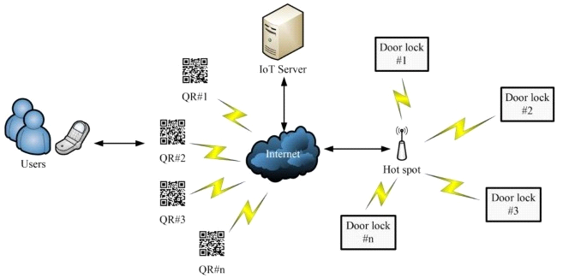

**Figure:4.3 System architecture**

First, a face scan is scanned by a cell phone to transmit the location decoding information through the Internet for location verification. Then, the web-based classroom access control information system decodes the location and verifies the password. After the location and password verifications are passed, the information system must conduct the door lock match verification. If the user is authorized to use that door lock, and the time is within the authorized usage time, the information system connects over the Internet through the wireless access point to the IOT door lock. The lock opening signal is then transmitted to the IOT door lock to open it.

The face recognition transmits a coded website address to the information system for decoding. After the lock opening key has been verified to be the correct random code, the lock opening screen is opened so that the user can open the lock.

**Figure:4.4 Process of unlock the door**

1. Test environment and subjects Almost every student on campus has a cell phone, so the campus has a sufficient number of mobile devices. home are one of the best locations for the establishment of this access control system.

1. System test In this study, 10 test subjects were randomly selected for the system test. The test is presented in According to the test results listed in Table 1, the average lock opening time was 9.2 seconds, and the lock was successfully opened at a 100% rate

**CHAPTER 5**

**SYSTEM IMPLEMENTATION**

**5.1 HARDWARE DESCRIPTION:**

**5.1.1 Camera Module(ESP32)**

**ESP32 can perform as a complete standalone system or as a slave device to a host MCU**, reducing communication stack overhead on the main application processor. ESP32 can interface with other systems to provide Wi-Fi and Bluetooth functionality through its SPI / SDIO or I2C / UART interfaces.The ESP32 is the ESP8266 successor loaded with lots of new features. The ESP32 is a development board that combines Wi-Fi and Bluetooth wireless capabilities, and it’s dual core.

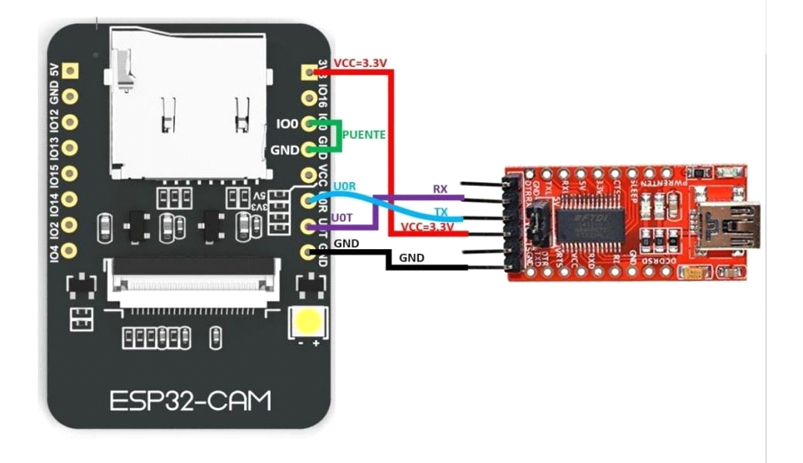

**Figure:5.1 ESP32 Camera Module**

**5.1.2 Solenoid Lock**

The DC 12V Cabinet Door Lock Electric Lock Assembly Solenoid is used for locking sell machine, storage shelf, file cabinet etc. There is a hidden way of unlocking which is used in case of emergency. The lock works as the circuits disconnects, and it will unlock when the circuit is powered-on. These are steady, durable, and energy-saving and have along lifespan. The lock is better than other kinds of locks in anti-theft and shockproof design. The electric lock can control the door’s opening and closing, after connecting the wires and when the current is available.

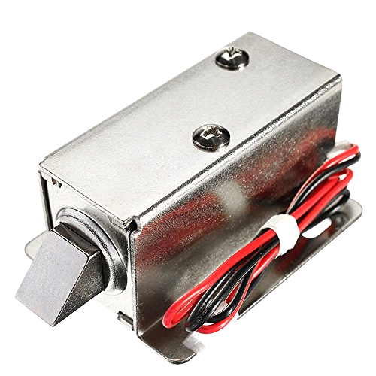

**Figure:5.2 Solenoid lock**

**5.1.3 Piezo Buzzer**

Piezo buzzer is a simple device that can generate basic beeps and tones. It is a lightweight device with a simple construction, and it is typically a low-cost product. It is also reliable and can be constructed in a wide range of sizes that work across varying frequencies to produce different sound outputs. They work by using a piezo crystal, which is a special material that changes shape when voltage is applied to it. If the crystal pushes against the diaphragm, like a tiny speaker cone, it generates a pressure wave which the human ear picks it up as sound LAN cable, bread board, SD card, SD card adapter, Pi enclosure, jumper wires, screws and connecting wires are the additional hardware components which are used to build the device.

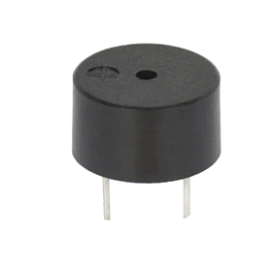

**Figure:5.3 Piezo buzzer**

**5.1.4 Adapter**

12 v 1 A Power Adapter **takes an AC INPUT of 100-240V and gives 12V 1A DC output**. **12 V DC 1 A power supply** is suitable for powering a wide range of applications including CCTV cameras, wireless routers, Robotics and DIY kits.

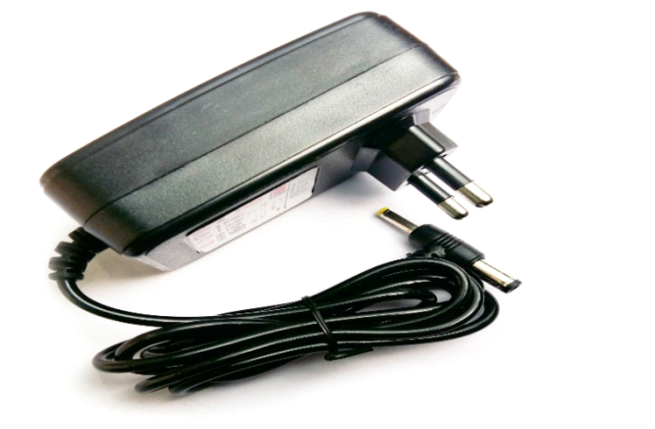

**Figure:5.4 Adapter(12volt)**

**5.1.5 HC-05 Bluetooth Module**

**HC-05 Bluetooth module** offers two ways of communication for shorter distances with fast speed. It has an enable pin which allows toggling between command and data mode. The device uses UART (serial communication) which is easy to interface with any microcontroller or system.

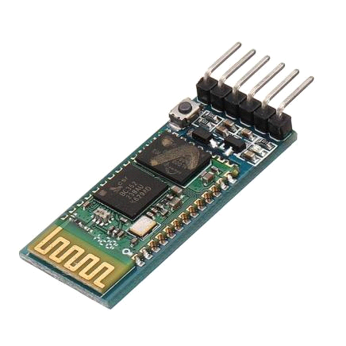

**Figure:5.5 HC05 Bluetooth Module**

**5.1.6 Relay**

An electromagnet activates a relay when a little quantity of current is provided to the signal pin. The 1-Channel 5V Relay Module is 5V 1-Channel relay interface board with screw terminals that may be controlled Arduino, AVR, PIC and ARM microcontrollers. A high-quality relay is included on the board, which can be handle up to 15 amps at 125 volts and 10 amps at 250 volts. The common-C, normally open-NO, and normally closed- NC connections on the relay are all attached to three pin screw terminals, making connecting and disconnecting the relay a breeze. The board contains a power indicator and a relay status LED to aid debugging.

Relays are mainly made for two basic operations. One is low voltage application and the other is high voltage. For low voltage applications, more preference will be given to reduce the noise of the whole circuit. For high voltage applications, they are mainly designed to reduce a phenomenon called arcing.

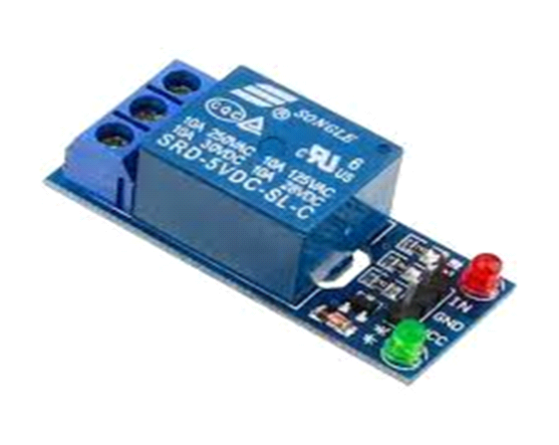

**Figure:5.6 Relay**

**5.2 SOFTWARE DESCRIPTION:**

**5.2.1 Node MCU with Arduino IDE (ESP 8266 setup)**

1) Download Arduino IDE.

2) Open your IDE and click on File -> Preferences

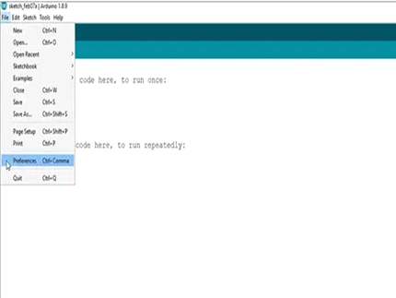

3) In Additional Boards Manager URLs add this line and click on ok button.http://arduino.esp8266.com/stable/package_esp8266com_index.json.

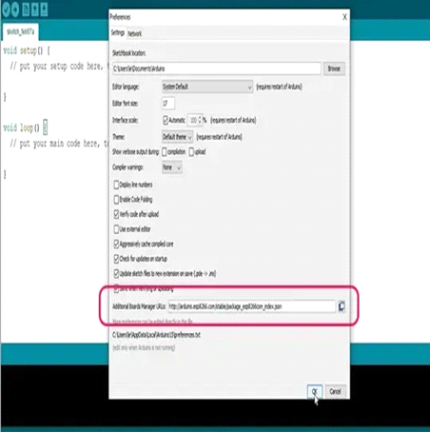

4)Go to Tools -> Board -> Boards Manager type “ESP8266” and install it.

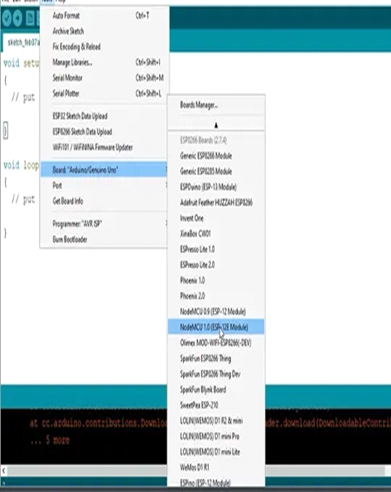 5) Go again to Tools -> Board and select Node= MCU 1.0 (ESP-12E Module)

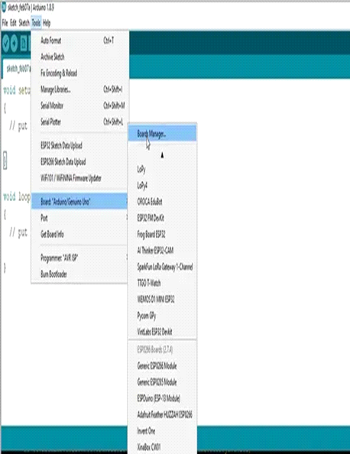

Getting started with Node MCU ESP 8266 using LED blink Example

D0 has an on board LED, now we will write our first program to blink the LED, code uploading is the same as Arduino.

Code –

void setup()

{

pinMode(D0, OUTPUT);

}

void loop()

{

digitalWrite(D0, HIGH);

delay(500);

digitalWrite(D0, LOW);

delay(500);

}

Once the code is uploaded you can see LEDis blinking with a delay of 500 millisecond.

**5.2.2 Python**

Python is a powerful programming language and is easy to learn. It has high-level data structures and an effective approach to object-oriented programming. Python’s elegant syntax, dynamic typing, along with its interpreted nature; makes it an ideal language for scripting and rapid application development in many areas on most platforms.

The Python interpreter and the extensive standard libraries are freely available in source or in the binary form for all major platforms from the Python website and can be freely distributed. The same site also contains distributions and pointers to many third-party free Python modules, programs and tools, and additional documentation.

The Python interpreter can be easily extended with new functions and data types in Cor C++ (or other languages callable from C). For customizable applications, Python can be used as an extension language.

**5.2.3 Arduino Voice Control App**

Voice control is the ongoing IT task of analyzing a business network to discover IP addresses and identify relevant information associated with those IP addresses and devices. Armed with an IP range scanner, admins can set a specified range of addresses to discover any IP addresses within that range.

Select Start > Settings > Devices > Printers & scanners or use the following button. Open the Printers & scanners settings.

Select Add a printer or scanner. Wait for it to find nearby scanners, then choose

the one you want to use, and select Add device.

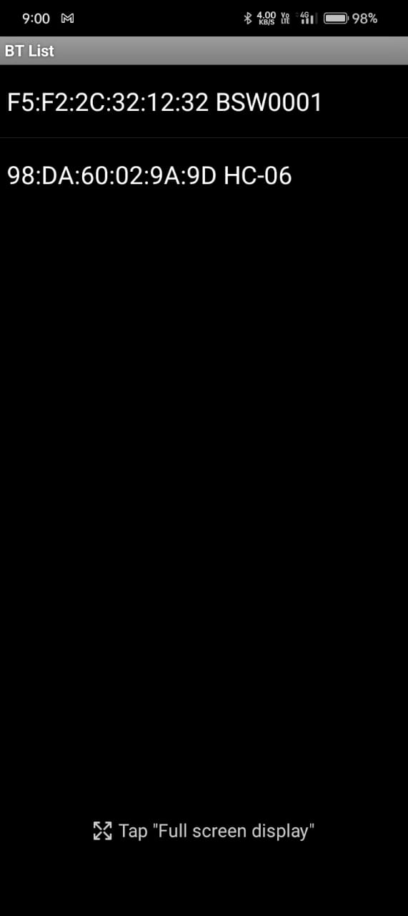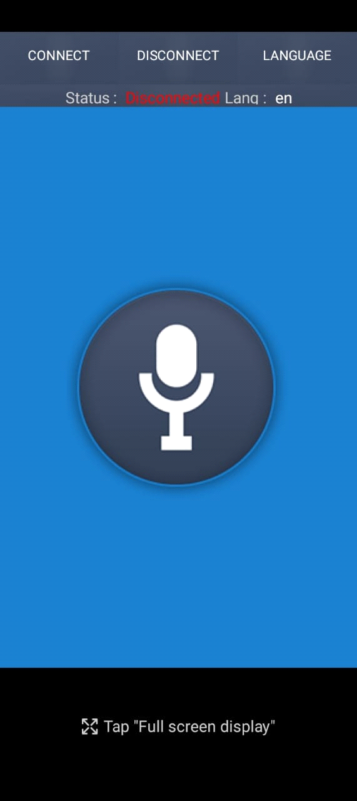

**Figure:5.7 Arduino Voice control connection.**

**CHAPTER 6**

**PERFORMANCE ANALYSIS**

**6.1 OVERVIEW**

According to the system test results, the average lock opening time was 9.2 seconds, and 100% of users successfully opened the lock. The wireless connection also simplified the installation. According to the analysis, typical equipment costs 4.8 times to 10.3 times as much as the proposed hardware. In addition, if the original campus already has electronic locks, only the IOT door lock network bridges are required. The proposed system can substantially reduce the cost, time, and manpower required for lock deployment and management. The classroom management can be done with door control that matches directly through the system.

|  |  |
| --- | --- |
| **Table 6.1Simulation Parameters** | |
| **Parameters** | **Values** |
| Camera Module(ESP32) | 600 |
| Relay | 350 |
| Adaptor(12v) | 180 |
| Solenoid lock | 550 |
| Piezo Buzzer | 30 |
| HC-05 Bluetooth Module | 20 |

**Performance comparison between model 1 and conventional model**

**6.2 The authentication speed results**

Five different residential access methods were tested a total of twenty times each. The residential access methods tested were residential access using a key, access to dormitory door by entering a six-digit password or using a key card, workplace access using a fingerprint, and access to a computer engineering laboratory using an RACs.

The results found that the RACs system took an average time of 5.63 seconds for authentication starting when the RACs application was opened. Residential access using a key, dormitory access using a six-digit password, dormitory access using a key card, and workplace access using a fingerprint took average times of 5.13 seconds , 4.78 seconds , 2.44 seconds , and 2.98 seconds respectively.

The RACs system took slightly more time than the other methods. This occurs because the RACs device uses a low-resolution camera device, and the ESP32 has a slow processing speed. Therefore, to reduce the access response time, the system switched to a high-resolution camera module and used a Raspberry Pi instead of the ESP32.

The RACs did not require keys or other objects compared to using keys or key cards. Besides, when using the RACs system, users do not need to touch the device, and this system is easier to register in the system compared to systems that use passwords or fingerprints.

Moreover, the RACs can also send keys from house owners to other users who are allowed to them to access the house. Therefore, the RACs are safer and more flexible than the comparative methods.

**6.3 The security performance results**

We tested the security of the RACs by creating a fake QR code using the algorithm of this paper. The results showed that the intruder could not use the fake QR code to gain access because when the fake QR code is combined with a salt message on the key server, it will generate an invalid hash and cannot match the RACs device's hash value.

Besides, the same QR code could not be used to access the residence because the system would only allow the QR code to be used one time and would randomly generate a new secret code to prevent an intruder from having the correct QR code.

Finally, in the worst case in which an intruder could access a residence, the house owners would know this immediately via a notification message or viewing the log via . Moreover, to prevent data from being stolen during the data transmission between RACs devices and the key server, the RACs uses transport layer security communication.

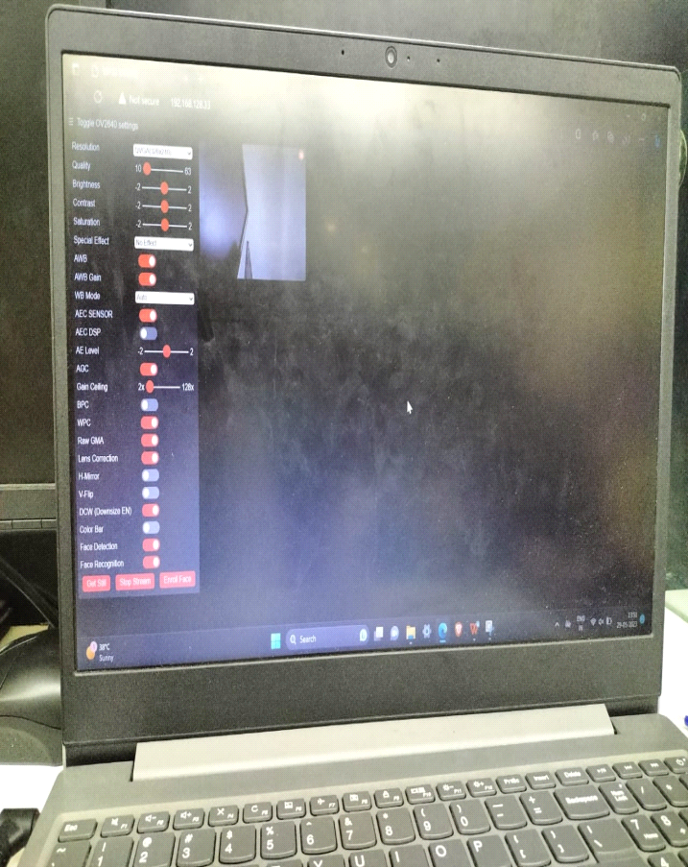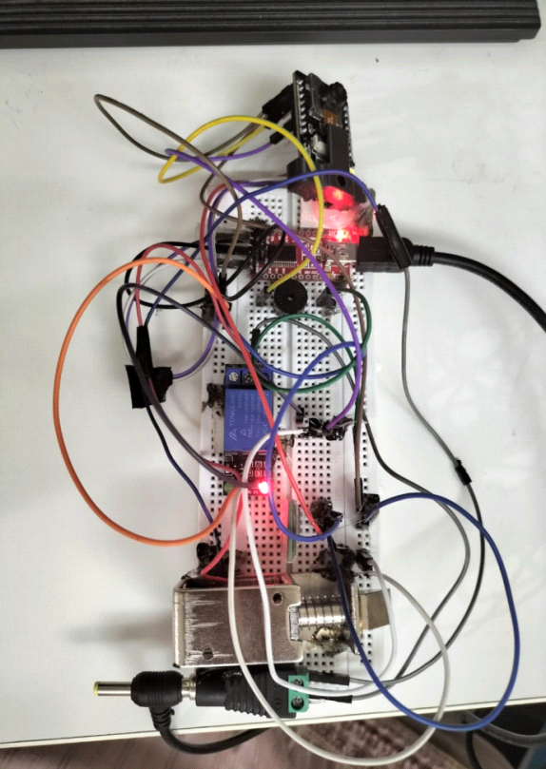

**Figure:6.1 Face Enrolling webpage Figure:6.2 Hardware kit**

**CHAPTER 7**

**CONCLUSION**

**7.1 CONCLUSION**

This project will make human lives more versatile with enhanced security, ease, and the ability to live an upper-class lifestyle, resulting in our lives becoming much simpler, finer, accessible, and stable. The cost of implementing the designed system has been kept low, making it affordable To Everyone is looking for home security. In contrast to the majority of the technologies described in the literature review, the Iot-based door lock system is simple to implement and manage. It supports IoT, cellular technology, and an open-source Android system platform that is not proprietary. The proposed system intends to address the shortcomings of the current system and to improve it by implementing certain innovative ideas suggested by some related publications. According to the system test results, the average lock opening time was 9.2 seconds, and 100% of users successfully opened the lock. The wireless connection also simplified the installation. According to the analysis, typical equipment costs 4.8 times to 10.3 times as much as the proposed hardware. In addition, if the original campus already has electronic locks, only the IOT door lock network bridges are required. The proposed system can substantially reduce the cost, time, and manpower required for lock deployment and management. The classroom management can be done with door control that matches directly through the system. Having a security system to a home is advantageous and secure. Many people cannot afford the security systems and this project describes how we can use simple equipment effectively and with less cost.

**7.2 SCOPE FOR FUTURE WORK**

In future, the android application should display support in controlling more doors, windows and basic home electronic appliances. An auto trigger report of the attempt to theft can be sent to nearest police station along with domestic address. This idea can be considered to make the proposed system better. In the future, we will develop more complex cryptography algorithms and implement a high-performance device that will result in faster processing times. Unintentional unlocking could be solved with a similar solution using GPS technology.

|  |
| --- |
| **REFERENCES** |
| * Arpita Mishra, Siddharth Sharma, Sachin Dubey, S.K. Dubey, “Password Based Security Lock System”, International Journal of Advanced Technology in Engineering and Science, 2011 |
| * Bhalekar Pandurang, Jamgaonkar Dhanesh, Prof. Mrs. Shailaja Pede, Ghangale Akshay, Garge Rahul, “Smart Lock: A Locking System Using Bluetooth Technology & Camera Verification”, International Journal of Technical Research, 2013. |
| * Lia Kamelia, Alfin Noor hassan S.R, Mada Sanjaya and W.S., Edi Mulyana “Door-Automation System Using Bluetooth-Based Android For Mobile Phone”, ARPN Journal of Engineering and Applied Sciences(ISSN 1819-6608), Vol. 9, No. 10, October 2014. |
| * Neelam Majgaonkar, RuhinaHodekar, Priyanka Bandagale, “Automatic Door Locking System”, International Journal of Engineering Development and Research, Volume 4, Issue 1,2013 ISSN: 2321- 9939 |
| * R.A. Ramlee, D. H. Z. Tang, M.M.Ismail, “Smart Home System for Disabled People Via Wireless Bluetooth”, in Proc. of IEEE International Conference on System Engineering and Technology, pp. 1-4, 2012 |
| * Jae Hoon Lee; Yong-Shik Kim; Bong Keun Kim; Ohba, K.; Kawata, H.; Ohya. A.; Yuta, S. “Security Door System Using Human Tracking Method with Laser Range Finders”, IEEE International Conference on Mechatronics and Automation2007. ICMA 2007 |
| * Priyanka Bhogade, “QR Based Advanced Authentication for Online Transactions”, International Journal of Engineering Research & Technology (IJERT), Vol. 3, Issue. 2, February 2014. |
| * U. Farooq, M. Hasan, M. Amar, A. Hanif, and M. U. Asad, “RFID Based Security and Access Control System,” Int. J. Mod.Trends Sci. Technol., vol. 57, no. 4, 2016. |
| * H. A. M. Md. Salahuddin Ahamed, “A Secure QR Code System for Sharing Personal Confidential Information,” in International Conference on Computer, Communication, Chemical, Materials and Electronic Engineering (IC4ME2),2019, pp. 11–12. |
| * Chinmay Jathar, Swapnil Gurav and Krantee Jamdaade, “A Review on QR Code Analysis” International Journal of Application or Innovation in Engineering & Management (IJAIEM) Volume 8, Issue 7, July 2019. |
| * Kushank Sehgal and Richa Singh, “Iot Based Smart Wireless Home Security Systems” Proceedings of the Third International Conference on Electronics Communication and Aerospace Technology [ICECA 2019] IEEE Conference Record # 45616; IEEE Xplore ISBN: 978-1-7281-0167-5. |
| * H. A. M. Md. Salahuddin Ahamed, “A Secure QR Code System for Sharing Personal Confidential Information,” in International Conference on Computer, Communication, Chemical, Materials and Electronic Engineering (IC4ME2),2019, pp. 11–12. |
| * Ha, "Security and usability improvement on a digital door lock system based on internet of things," International Journal of Security and Its Applications, vol. 9, no. 8, pp. 45-54, 2015. |
| * Presso, M., Scafati, D., Marone, J., and Todorovich, E., "Design of a smart lock on the galileo board," 2017 Eight Argentine Symposium and Conference on Embedded Systems (CASE), Buenos Aires, 2017, pp. 1-6, doi: 10.23919/SASE-CASE.2017.8115378. |

**APPENDIX-1**

**CODING**

#include "esp_camera.h"

#include <WiFi.h>

//

// WARNING!!! Make sure that you have either selected ESP32 Wrover Module,

//            or another board which has PSRAM enabled

//

// Select camera model

//#define CAMERA_MODEL_WROVER_KIT

//#define CAMERA_MODEL_ESP_EYE

//#define CAMERA_MODEL_M5STACK_PSRAM

//#define CAMERA_MODEL_M5STACK_WIDE

#define CAMERA_MODEL_AI_THINKER

#include "camera_pins.h"

const char* ssid = "Padmanaban";

const char* password = "9994313461";

#define LED_BUILTIN 4

#define relay 4

#define buzzer 2

boolean matchFace = false;

boolean activeRelay = false;

long prevMillis = 0;

int interval = 5000;

void startCameraServer();

void setup() {

  Serial.begin(115200);

  Serial.setDebugOutput(true);

  Serial.println();

  pinMode(relay, OUTPUT);

  pinMode(buzzer, OUTPUT);

  pinMode (LED_BUILTIN, OUTPUT);

  digitalWrite(LED_BUILTIN, LOW);

  digitalWrite(relay, LOW);

  digitalWrite(buzzer, LOW);

  camera_config_t config;

  config.ledc_channel = LEDC_CHANNEL_0;

  config.ledc_timer = LEDC_TIMER_0;

  config.pin_d0 = Y2_GPIO_NUM;

  config.pin_d1 = Y3_GPIO_NUM;

  config.pin_d2 = Y4_GPIO_NUM;

  config.pin_d3 = Y5_GPIO_NUM;

  config.pin_d4 = Y6_GPIO_NUM;

  config.pin_d5 = Y7_GPIO_NUM;

  config.pin_d6 = Y8_GPIO_NUM;

  config.pin_d7 = Y9_GPIO_NUM;

  config.pin_xclk = XCLK_GPIO_NUM;

  config.pin_pclk = PCLK_GPIO_NUM;

  config.pin_vsync = VSYNC_GPIO_NUM;

  config.pin_href = HREF_GPIO_NUM;

  config.pin_sscb_sda = SIOD_GPIO_NUM;

  config.pin_sscb_scl = SIOC_GPIO_NUM;

  config.pin_pwdn = PWDN_GPIO_NUM;

  config.pin_reset = RESET_GPIO_NUM;

  config.xclk_freq_hz = 20000000;

  config.pixel_format = PIXFORMAT_JPEG;

  //init with high specs to pre-allocate larger buffers

  if(psramFound()){

    config.frame_size = FRAMESIZE_UXGA;

    config.jpeg_quality = 10;

    config.fb_count = 2;

  } else {

    config.frame_size = FRAMESIZE_SVGA;

    config.jpeg_quality = 12;

    config.fb_count = 1;

  }

#if defined(CAMERA_MODEL_ESP_EYE)

  pinMode(13, INPUT_PULLUP);

  pinMode(14, INPUT_PULLUP);

#endif

  // camera init

  esp_err_t err = esp_camera_init(&config);

  if (err != ESP_OK) {

    Serial.printf("Camera init failed with error 0x%x", err);

    return;

  }

  sensor_t * s = esp_camera_sensor_get();

  //initial sensors are flipped vertically and colors are a bit saturated

  if (s->id.PID == OV3660_PID) {

    s->set_vflip(s, 1);//flip it back

    s->set_brightness(s, 1);//up the blightness just a bit

    s->set_saturation(s, -2);//lower the saturation

  }

  //drop down frame size for higher initial frame rate

  s->set_framesize(s, FRAMESIZE_QVGA);

#if defined(CAMERA_MODEL_M5STACK_WIDE)

  s->set_vflip(s, 1);

  s->set_hmirror(s, 1);

#endif

  WiFi.begin(ssid, password);

  while (WiFi.status() != WL_CONNECTED) {

    delay(500);

    Serial.print(".");

  }

  Serial.println("");

  Serial.println("WiFi connected");

  startCameraServer();

  Serial.print("Camera Ready! Use 'http://");

  Serial.print(WiFi.localIP());

  Serial.println("' to connect");

}

void loop() {

    if (matchFace == true && activeRelay == false){

      activeRelay = true;

      digitalWrite (relay, HIGH);

      digitalWrite (buzzer, HIGH);

      delay(800);

      digitalWrite (buzzer, LOW);

      prevMillis = millis();

    }

    if(activeRelay == true && millis()- prevMillis > interval){

      activeRelay = false;

      matchFace = false;

      digitalWrite(relay, LOW);

    }

}

**APPENDIX-2**

**SCREENSHOT**

**1.Loading the code into node MCU module:**

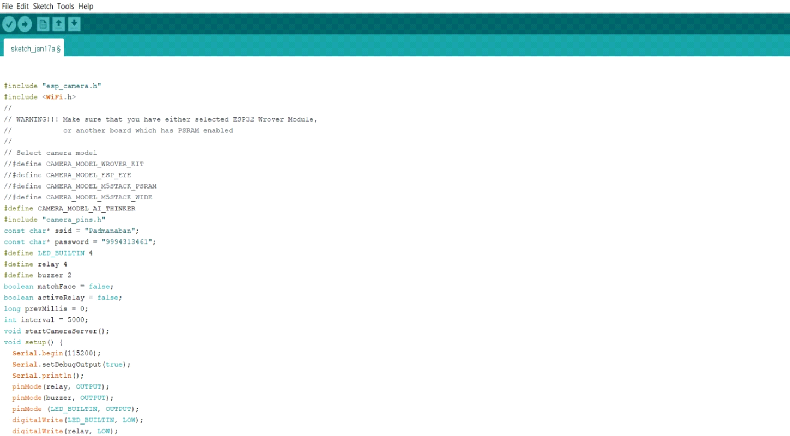

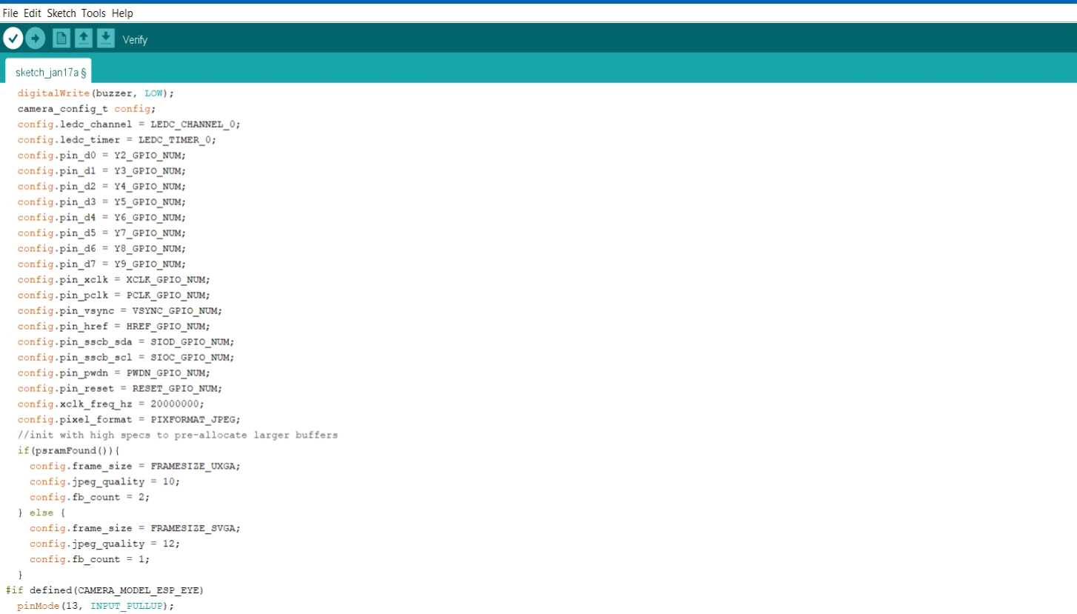

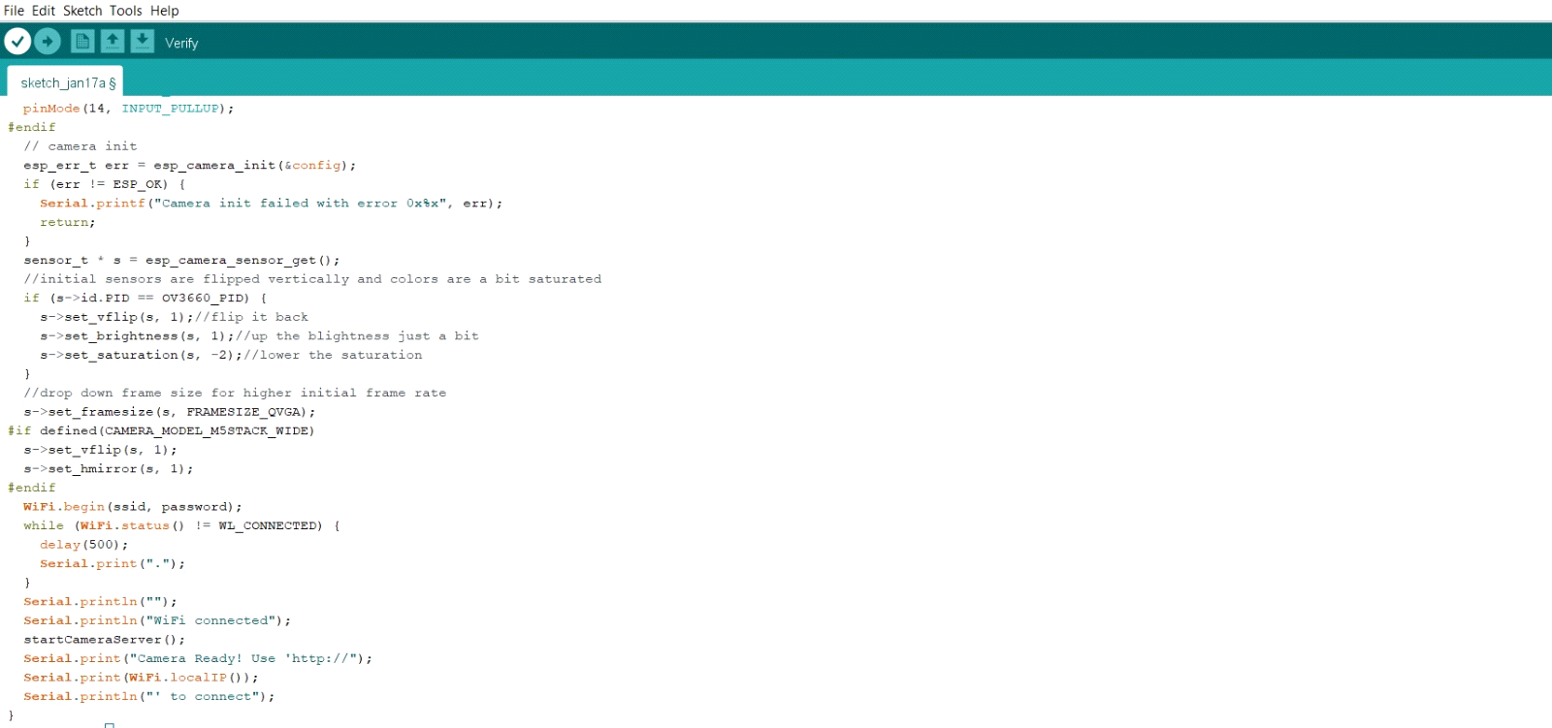

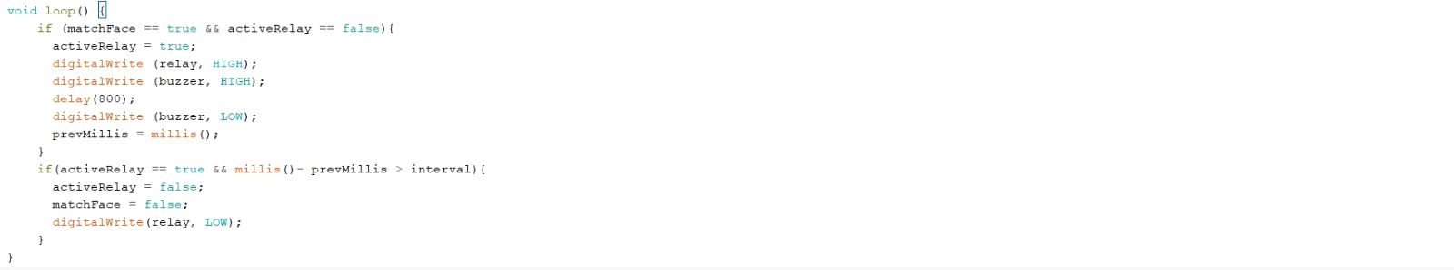

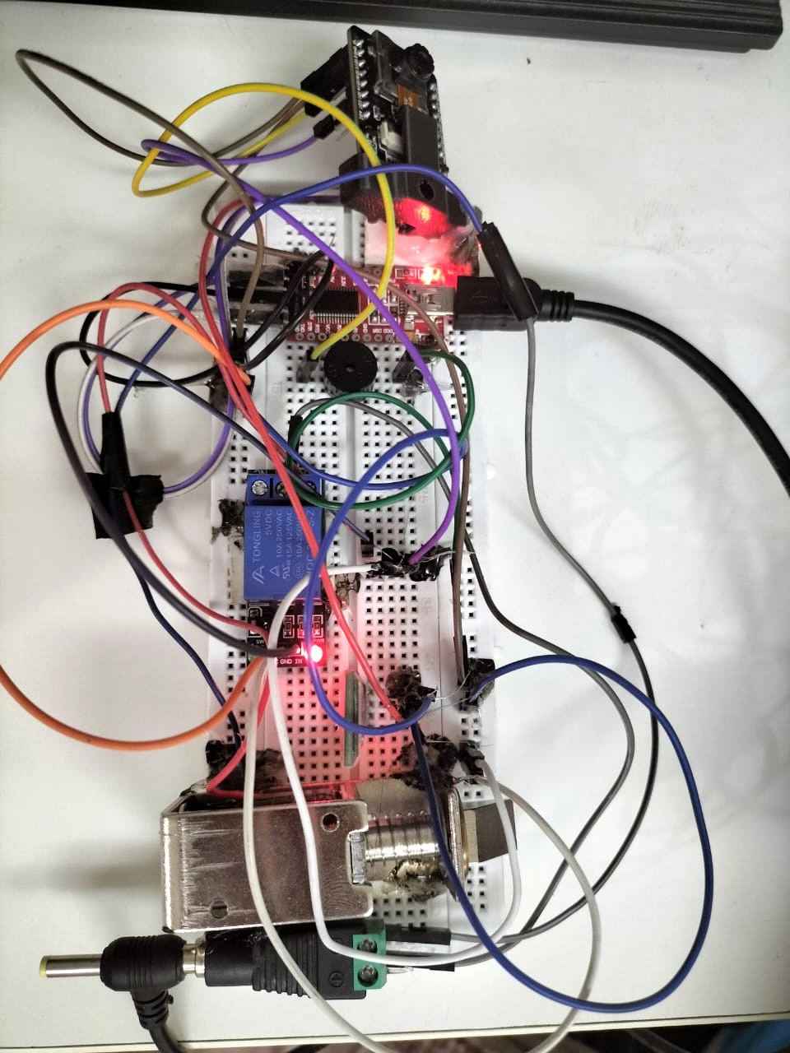  
**2. Connection:**

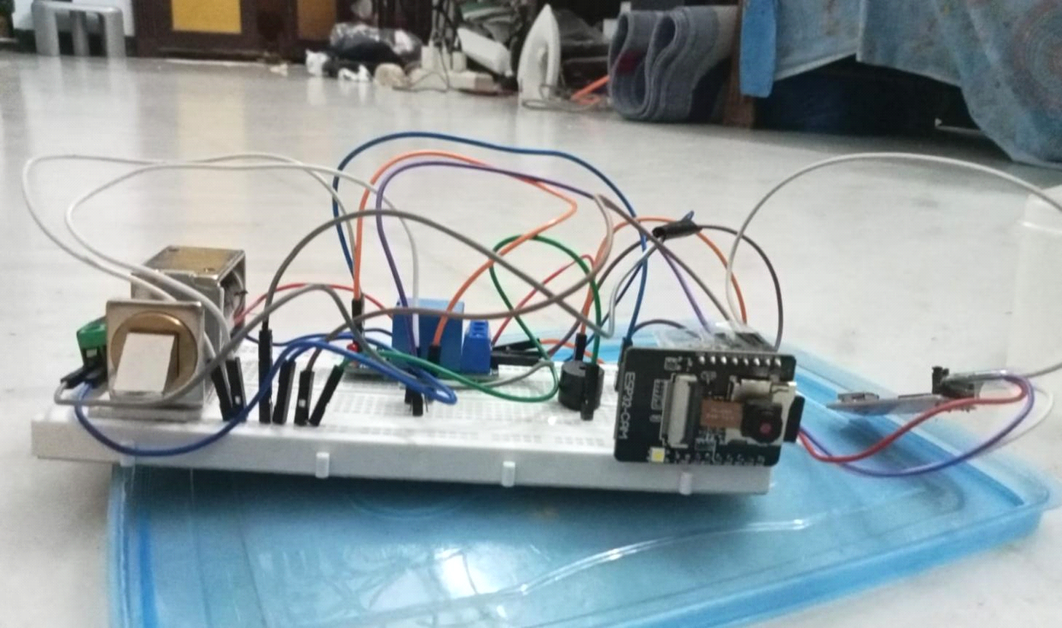

**3.Output1:**

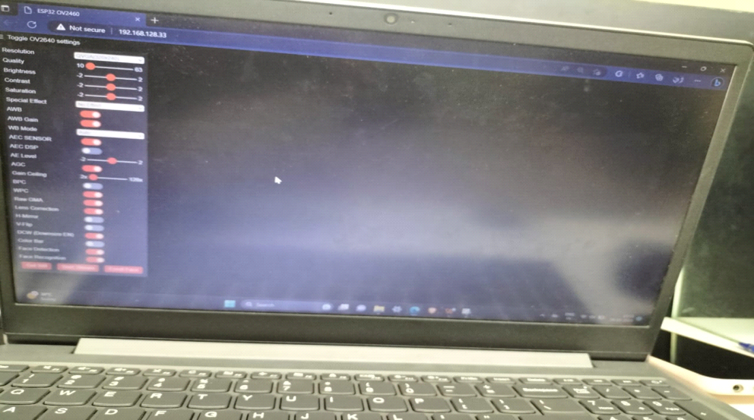

**Output before start stream for face detection and face recognition options**

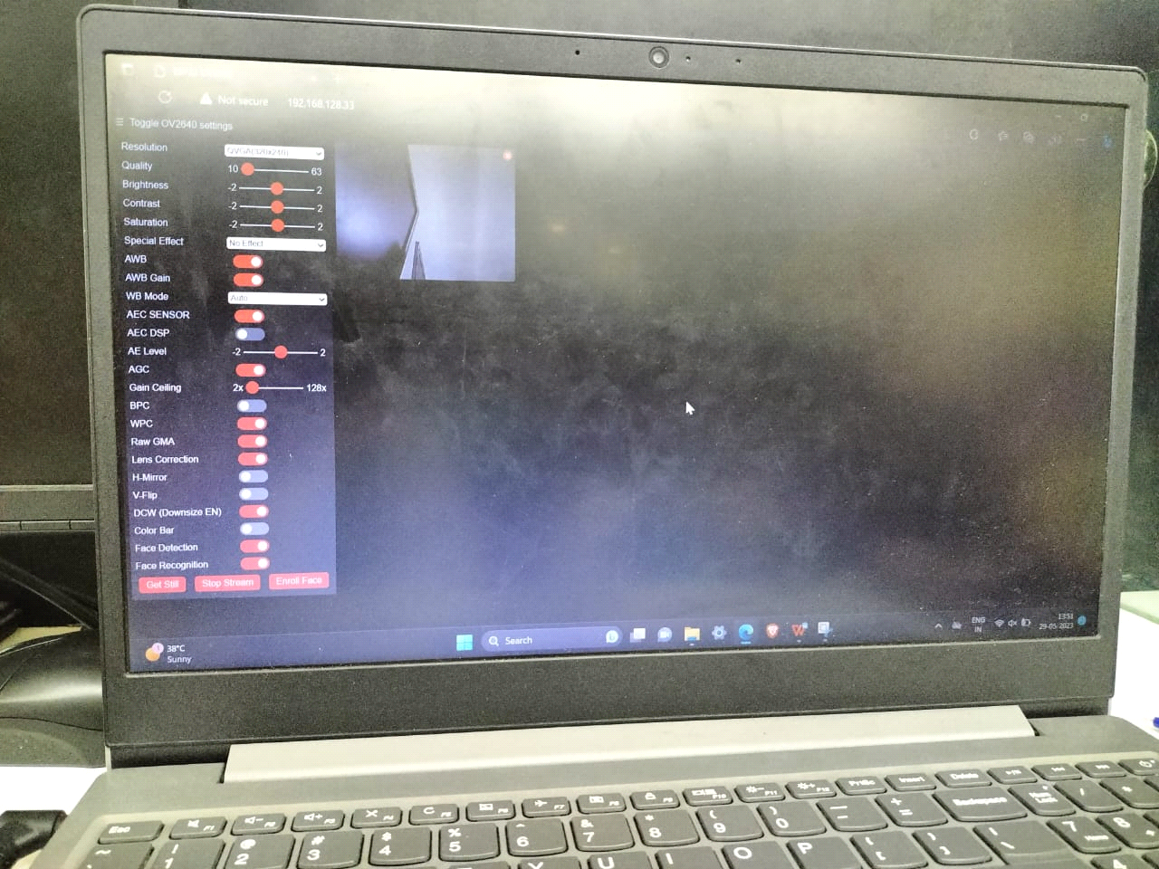

**Output for after start stream and face detection option.**

**Face recognition: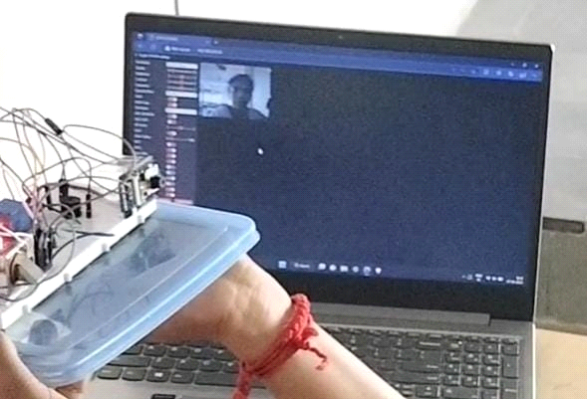Voice module result:**



**Mini Project Expo Held On 31.05.2023**

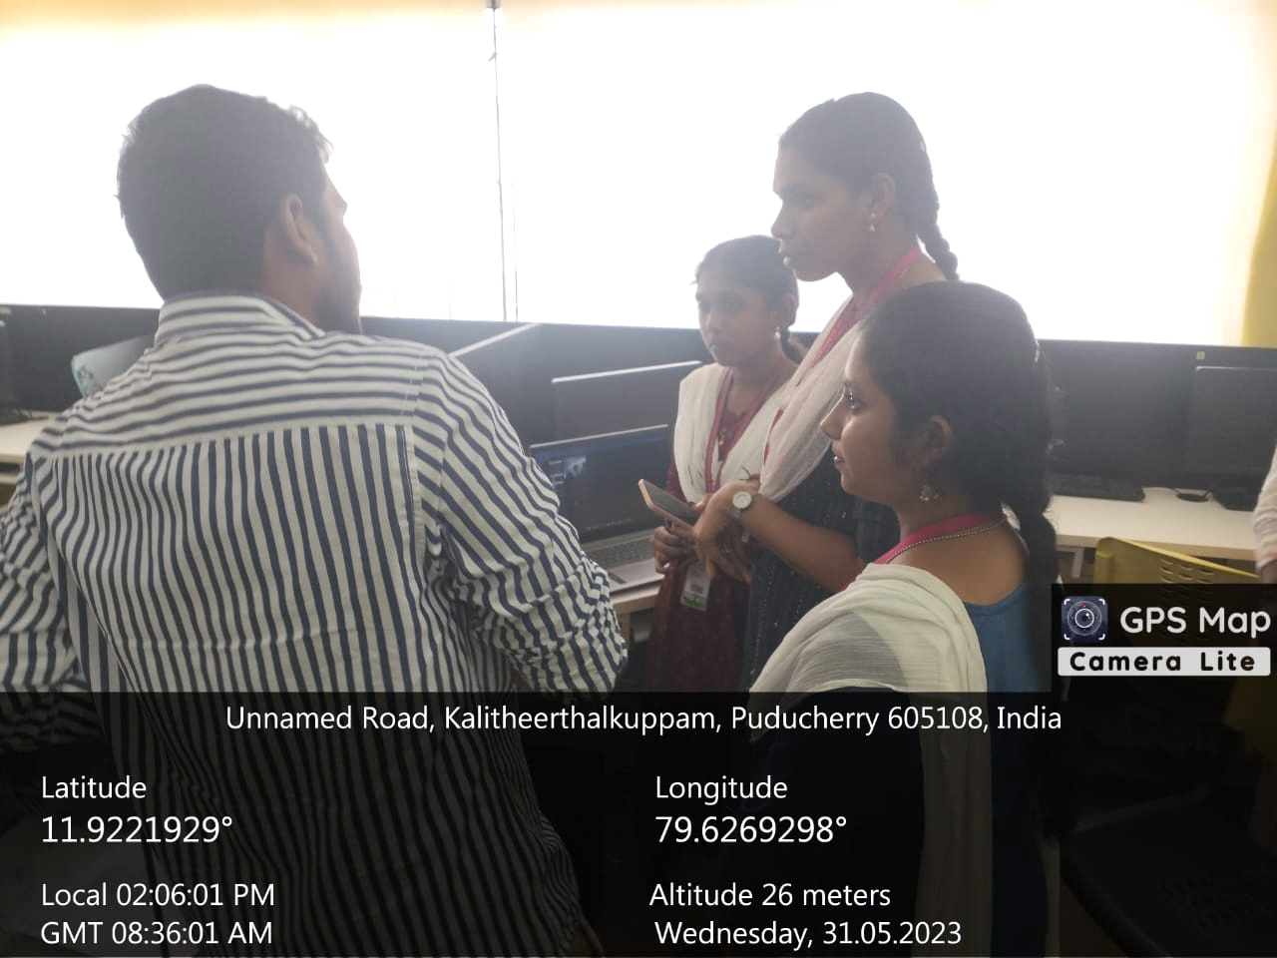

**Our Project demonstrated in Project Expo “International Technology Week”, held on 31.05.2023 and verified by the internal and external juries.**